Week 13 – In class Assignments

I listed the different majors under the Polytechnic Institute at Purdue University.

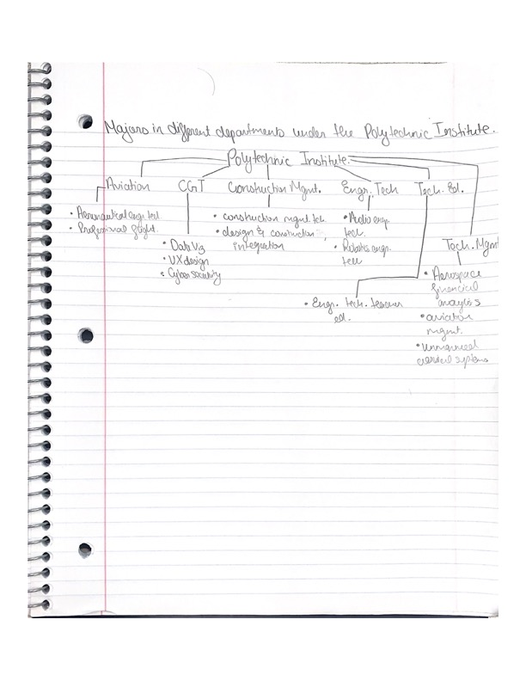

Example found online:

URL: https://searchstorage.techtarget.com/definition/file-system

